****Name: __________________________________ Date: ________________ Block: ________

**Vocabulary List #1**

**Prefixes with negative meanings**

***Prefix: letters added to the beginning of a word that change the word’s meaning***

**All of these prefixes mean “not,” “without,” or “the opposite of”**

Un-

1. unadorned = (adj.) not decorated, plain, bare
2. unblemished = (adj.) free from spots or stains

Non-

1. nonpartisan = (adj.) not supporting any political group, unbiased
2. nonexistent = (adj.) not real or present, imaginary

A-

1. asymmetric = (adj.) having no balance or symmetry, not identical
2. apathy = (noun) having no emotion, passion, excitement; lacking interest

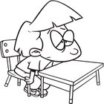An-

1. anemia = (noun) lack of vitality or vigor (also a medical condition

resulting from lack of iron)

1. anarchy = (noun) a state of disorder, lacking authority, chaos

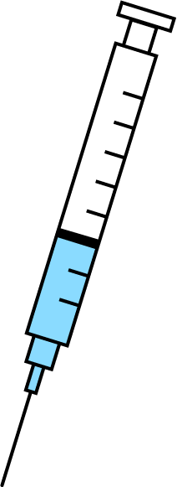Anti-

1. antibiotic = (noun) a medicine that stops the growth of organisms
2. antidote = (noun) a remedy for counteracting a poison or disease

Dis-

1. disorientated (verb) = to lose one’s sense of direction, to become confused
2. disarm (verb) = to remove one’s weapons or method of attack

In-

1. inaccurate (adj.) = not correct; wrong; erroneous
2. insignificant (adj.) = petty; unimportant; not worthy of consideration

Im-

1. immature = (adj.) not fully grown or developed
2. 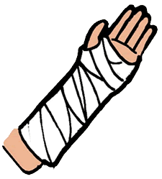immobilize= (v) to prevent something from moving or operating as normal

Il-

1. illiterate = (adj.) unable to read or write
2. 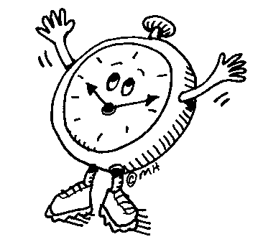illegible = (adj.) not clear enough to be read; undecipherable

Ir-

1. irreversible = (adj.) not able to be undone or altered
2. irreverent = (adj.) showing a lack of respect for things that are usually taken seriously

*On looseleaf, write a GOOD sentence for each vocabulary word. You may change the word ending to fit your sentence (like adding –ing or –ed).*