Name:____________________________ Date:__________________ Block:_________
Roots: List #2
chron- (time)
- chronological: (adj): to arrange in the order of time (earliest date to most recent)
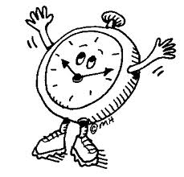
- synchronize (v): to happen at the same time; simultaneous
biblio-/libr- (book)
- bibliophile: (n): a person who loves books
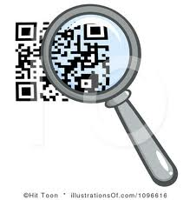
- librarian: (n): a person who specializes in the care and management of books
crypt- (hidden)
- cryptic: (adj): having hidden meaning; secret; encoded
- encryption: (n): the process of putting information into code so that others cannot read it
cred- (believe)
- credential: (n): something that entitles a person to trust or power; something one shows in order to be believed (like a pass or a letter)
- incredible: (adj): too extraordinary to be believed; unimaginable; fantastic
culp- (guilty)
- culpable: (adj): deserving of blame for a negative act; guilty; wrong
- culprit: (n): one who is guilty of a crime or at fault; the source of the problem
equi- (equal)
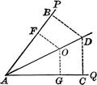
11) equinox: (n): the two times each year (March 21 and September 23) when day and night are everywhere on earth are equal length
12) equidistant: (adj): an equal distance from two points
magn- (large)
13) magnify: (v): causing objects to appear larger than they are; exaggerate; enlarge
- magnanimous: (adj): showing generosity; showing a lofty sense of goodness

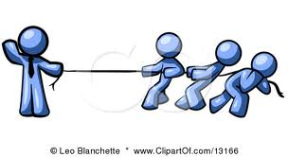
min- (small)
- miniscule: (v): very small; tiny; barely able to be seen
- minority : (n): the smaller in number of two groups that make up a whole
spir- (breath)
17) respiration: (v): the complete act of breathing; taking a breath
18) conspire:(v): to join in a secret agreement to do something unlawful; plot; scheme
terr- (earth)
19)extraterrestrial: (adj/n): coming from or existing outside the planet Earth; alien
20) terrarium: (n): a glass or plastic box used for growing plants or keeping small
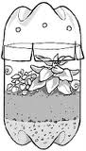
animals indoors; creating a segment of Earth inside a protected box

Write a GOOD sentences for each vocabulary word.

