Name:____________________________ Date:__________________ Block:_________
Suffixes: List #3
-meter (measuring device)**
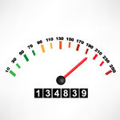
- perimeter: (n): a continuous line that forms the boundary of a figure; the measure of the length of the boundary
- odometer: (n): a instrument that measures the distance traveled by a vehicle
-ist (one who does something)**
- florist (n): a person who grows and sells flowers and ornamental plants
- optimist: (n): a person who expects a favorable outcome; someone who looks on the bright side of life
-mania/maniac (unreasonable desire for)**
- egomaniac: (n): one who is preoccupied with themselves; narcissistic; unreasonably worried with one’s appearance
- kleptomaniac: (n): an unreasonable desire to steal things; uncontrollable impulse to take things that belong to others
-ous (full of)**
- odorous: (adj): having a strong smell that is usually bad; stinky; full of a scent
- erroneous: (adj): full of mistakes; containing wrong information
-ty (quality)
- eccentricity: (n): the quality of being strange or abnormal; having a habit that is unusual
- vanity: (n): the quality of having too much pride in one’s appearance or abilities
-tude (state of)**
11) altitude: (n): the height of something above sea level; elevation
12) magnitude: (n): greatness in size or importance; the power of something

-ism (act of)
13) capitalism: (n): an economic system in which people can own, sell, and buy
property in exchange for money; free market
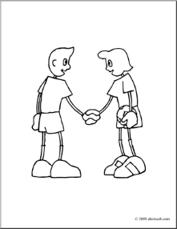
- criticism: (n): the act of expressing disapproval; pointing out the problems or faults
-ship (quality of being )
- sportsmanship (n): the quality of playing fair; being respectful of one’s opponents; polite behavior while competing in sports
- citizenship: (n): the qualities expected of someone who is a responsible member of a community or country
-ness (state of)
17) tardiness: (n): the state of being late; the quality of being slow moving; being behind schedule
18) immenseness:(n): the state of being extremely large; huge; beyond being able to be measured
-some (tending to be)**
19) cumbersome: (adj): tending to be difficult to carry because of weight or shape; hard to manage
20) irksome: (adj): tending to be annoying; causing irritation
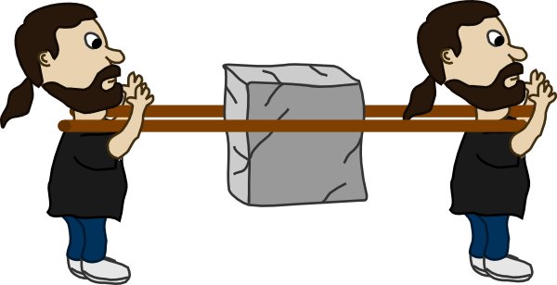

Write a GOOD sentences for each vocabulary word. Try to put two in one sentence or make up a story for extra bonus!

