Name:____________________________ Date:__________________ Block:_________
Suffixes: List #2
-ery (the practice of, the act of)
- mastery: (n):having great skill or technique; the act of being superior at something
- treachery: (noun): a violation of loyalty; the act of breaking one’s trust; treason
-ic (characteristic of)
- epic: (adj): extending beyond the ordinary or usual; (FYI: noun is a type of poem)
- acrobatic: (adj): the ability to perform gymnastic skills with one’s body; flexible
-ify(to make, to cause)
- exemplify: (v): to serve as an example; to be the perfect example; typical of something
- beautify:(v): to add attractiveness; to make more beautiful
-less (without)
- ceaseless (adj): continuing without end; constant; unending; nonstop
- effortless: (adj): easy; simple; requiring very little effort
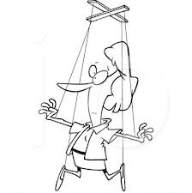
-like (like, characteristic of)
- phantomlike: (adj): ghostlike; existing only in appearance, having no substance
- puppetlike: (adj): feeling like one is being controlled like a puppet
-ology (the study of)
11) herpetology: (n): a branch of zoology that studies reptiles and amphibians
12) meteorology: (n): the science that deals with the atmosphere, weather and
weather forecasting

-ly (resembling)
13) abrasively: (adv): causing irritation; bothersome, rudely
- blandly: (adv): having no flavor; smooth; showing no emotion

-ment (state or quliaty of)
- bewilderment: (n): the state of being confused or disoriented; baffled or puzzled
- embellishment: (n): to make more beautiful by adding decoration or detail; exaggeration
-or (one who)
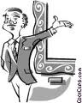
17) donor: (n): a person who gives away something that belongs to them
18) curator: (n): one who is in charge of taking care of a place like a
museum or zoo; someone who shows others around an exhibit
-ous (full of)
19) riotous: (adj): behaving in a violent and rowdy way; uncontrollable
20) advantageous: (adj): helpful, favorable; giving the advantage to someone

Write GOOD sentences for each vocabulary word. You can put them in one or a few short stories or combine more than one word per sentence. BUT, the word meaning must be clear!

