Name:____________________________ Date:__________________ Block:_________
Roots: List #1
aud- (sound)
- audible: (adj): loud enough to be heard
- audiologist (n): a person who identifies an helps people with hearing disorders
phon- (sound/voice)
- megaphone: (n): a cone shaped device for magnifying or making
one’s voice louder
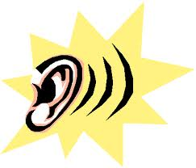
- cacophony: (n): a meaningless mixture of harsh sounds; boos; noise
son- (sound)
- sonic: (n): the speed of sound
- resonate: (v): to produce a deep clear sound that lasts a long time
dict- (say/speak)
- dictate: (v): to say or read something aloud to someone
- valedic torian: (n): the student with the highest academic scores who speaks during graduation
spect- (see/look)
- spectator: (n): a person who watches an event; a member of an audience
- retrospect: (n): to look back thoughtfully; to think about something that happened in the past
cogni- (to know)
11) recognize: (v): to know or identify someone or something
12) incognito: (adj): changing appearance so you will not be recognized; in disguise
graph- (write)
13) calligraphy: (n): elegant writing using special pens or brushes, decorative writing
used for formal events
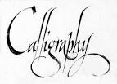
- bibliography: (n): a list of books that someone has used to find information for a
paper they have written
script- (write)
- manuscript: (n): a writer’s handwritten pages before the book has been published
- prescription: (n): a piece of paper that a doctor gives you that says what kind of
medication you need
tan/tact- (touch)
17) tangible: (adj): something that can be touched
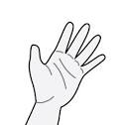
18) contact: (v): to be in a place where you meet someone or experience something
man- (hand)
19) manual: (adj): involving the use of one’s hands
20) manacles: (n): handcuffs; a chain joining the wrists

Write a GOOD sentences for each vocabulary word.

