Name:________________________ ____ Date:__________________ Block:_________
Quantity Prefixes
Hemi- / Semi- (half, part)
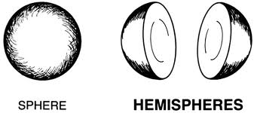
- hemisphere: (n) half of a sphere; half of the earth (northern/southern or eastern/western)
- semiannual: (adj) occurring twice a year
Uni- /Mono(one, single)
- unison: (n) two or more voices performing as one, simultaneous
- unique: (adj) being the only one of its kind, unlike anything else
- monochrome: (adj) consisting of varying tones of only one color; black and white
- monologue: (n) a long speech by one actor in a play or movie
Bi- /Di- /Du-(two, double)
7) biped: (n) a creature with two feet
8) bilingual: (adj) speaking two languages fluently
9) dilemma: (n) a difficult problem or choice that has to be made between two alternatives
10) duet: (n) a performance by two people
Tri- (three)
11) triathlon: (n) an athletic contest consisting of three different events (usually swimming, biking, running)
Penta- (five)
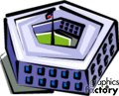
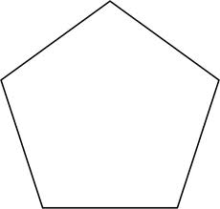
12) pentagon (n) a shape with five and five angles or when the p is capitalized: Pentagon: the building in Washington, DC that serves as the headquarters for the US Department of Defense

Oct- (eight)
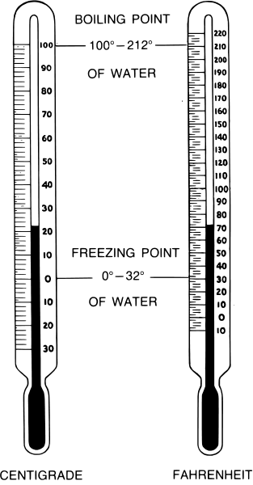
13) octogenarian: (n) a person who is from 80-89 years old
Dec- (ten)
14) decade: (n) a period of then years
Cent- (hundred)
15) centennial: (n) a hundredth anniversary
16) centigrade: (n) a temperature scale of a hundred degrees
Milli- (thousand)
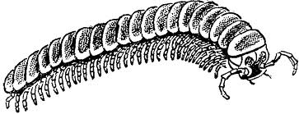
17) millipede: (n) a type of crawling insect with many (thousand) legs

Giga- ( billion)
18) gigabyte: (n) a storage unit for information of one billion bytes
Multi- / Poly- (many)
19) multimedia: (adj) Using more than one mode of expression or communication (internet, phone, video, text,)
20) polyester: (n) type of fabric made up of a many types of fibers

Write a GOOD sentences for each vocabulary word.

