Name:___________________________ Date:__________________ Block:_________
Prefixes with Opposite Meanings
Bene- (good, kind)
- benevolent: (adj): expressing goodwill or a desire to help others
- beneficial: (adj): helpful; favorable; resulting in good; advantageous
Mal-: (bad, evil)
- malevolent: (adj): wishing harm on others; showing ill will, evil, harmful
- dismal: (adj): causing gloom or dejection; dreary
Pro-: (forward)
5) propel: (v): to drive or move forward; to push onward
6) prodigy: (n): a person (especially a child) who has extraordinary talent or ability
Re-: (go backwards, again)
11) revise: (v): to change something that is already written or printed; to make improvements
12) recede: (v): to move away from; withdraw; retreat
Ab-: (Away from)
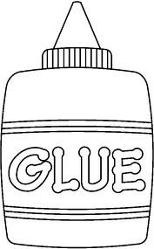
13) abduct: (v): to carry off or lead away in secret; kidnap
Ad- :(towards)
14) adhere: (v) to stay attached; to cling to; to stick fast
Pre- :(before)
15) prediction: (n): a statement about something that has not yet occurred; something that is told in advance; a prophecy
16) precede: (v) to go or be before; in advance

Post-: (after)
17) posthumously: (adj): happing or occurring after one’s death
18) postpone: (v): to put off until a later time
Sub-: (under)
19) submerge: (v): to sink below the surface of the water, to immerse or dunk underwater
Super- (above)
20) superior: (adj): above average in quality; better than average; excellent

Write a GOOD sentences for each vocabulary word.

