Name:_________________________________ Date:__________________ Block:____
EOG POWER Verbs!!!
1.) Infer: to draw a conclusion based on evidence; to make an educated guess based on information given in the text
Today would not be a good day for Billy, owner of Billy’s Fry Shack, for the health inspector had just walked through the screen door that had no screen. The flies scattered. Billy thought about the mousetraps on the floor and wondered if they had been emptied. “Mr. Billy?” inquired the health inspector. “We’ve received an anonymous tip about some unsanitary practices going on in the kitchen.” The cashier stared fearfully at the inspector, while the fry cook quickly looked down. Mr. Billy replied, “Well, our doors are always open to you, Inspector.” The inspector took the cap off of his pen.
What can you infer that the health inspector’s report will say?___________________________
_____________________________________________________________________________
What evidence do you have from the story to prove it? ________________________________
_____________________________________________________________________________
_____________________________________________________________________________

2.) Analyze: Break down an idea or a text into its details; to examine a text carefully and identify and interpret its parts
Analyze this sentence and identify the part of speech for each word.

A cat quickly chased the gray mouse around the table but it escaped.
___ ____ _____ ______ ____ ____ _____ _____ ____ ___ ____ ___ ______

3.) Signify: to be a sign of; to mean
What do the following things signify?
A diamond ring worn on the left hand of a woman? __________________________________
: ________________________________________________________

Pink Ribbons during the month of October: _________________________________________
A person carrying a white cane with a red tip________________________________________

4.) Trace: To outline; to list the steps of an activity
Trace the steps of getting a drink of water in your kitchen.______________________________
_____________________________________________________________________________
_____________________________________________________________________________
5.) Evaluate: to determine the importance or worth of a text; to judge
Evaluate three of the items from your lunch yesterday
_______________ :___________________________________________________
_______________ :___________________________________________________ _______________ :___________________________________________________

6.) Formulate: to put together; to plan; to create
Formulate a plan to get a good grade your quiz on commas on Thursday.
_____________________________________________________________________________
_____________________________________________________________________________
_____________________________________________________________________________

7.) Summarize: to give the main points; give a brief statement
Summarize the events of your past weekend.
____________________________________________________________________________
____________________________________________________________________________
____________________________________________________________________________

8.) Explain: to tell who, what, where, when or how; to make understandable
Explain the rules of tic tac toe ______________________________________________
____________________________________________________________________________
____________________________________________________________________________
____________________________________________________________________________

9.) Contrast: to identify the differences between two or more things
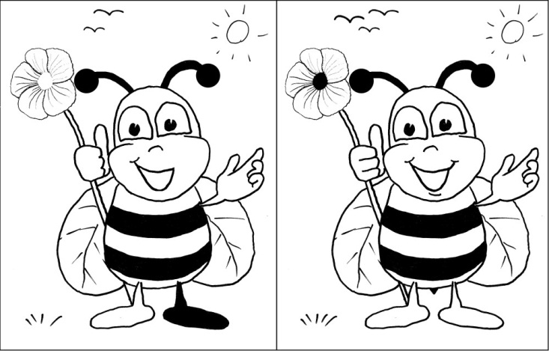
Find the contrasts:
1)_________________________________
2)_________________________________
3)_________________________________
4)_________________________________
5)_________________________________
6)_________________________________
7)_________________________________
8)_________________________________

10.) Compare: to identify the similarities between two or more things
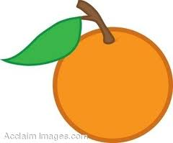
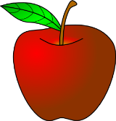
Find four comparisons: 1)____________________________________________
2)____________________________________________
3)____________________________________________
4)____________________________________________

11.) Predict: to make an educated guess as to what will happen next; to tell about the future

Dan has always been pretty independent. He has always been willing to do things for himself. His mom has gone to visit his aunt for the weekend, and Dan is home alone. Dan has a baseball game tomorrow, but his only uniform is dirty. Predict what Dan will do. ________________________
Make a prediction about what cars will look like in the year 2063. _____________________________
___________________________________________________________________________________
12.) Support: to back up with details; to give reasons
Students should be allowed to chew gum in school. Support your argument with three reasons why you feel this way.
1)_____________________________________________________________________
2)_____________________________________________________________________
3)_____________________________________________________________________

13.) Conclude: to reach a decision about something; to gather evidence & make a decision
Read the mystery. Then come to a conclusion that answers the final question.
A man was driving a black truck through a busy town. His truck lights were not on. The moon was not out. Suddenly a young girl stepped onto the road. The man swerved to avoid her. How did he see her? ______________________________________________

14.) Describe: to tell about; to give details about
Describe what your bedroom looks like. Draw a picture and label it.
______________________________________
______________________________________
______________________________________
______________________________________
______________________________________
______________________________________
______________________________________

